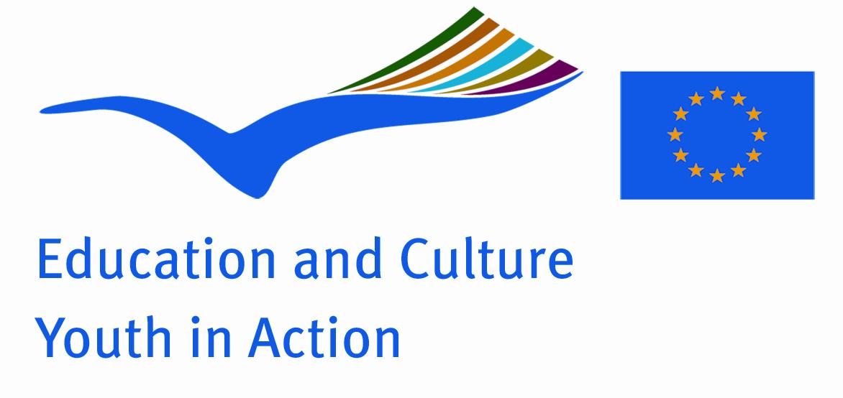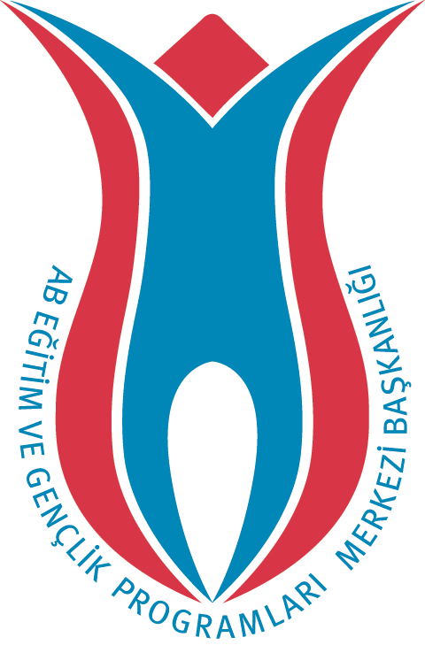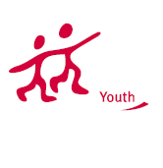

Action 1.1

Project Summary; Discussing the voluntarism, cultural differences and educational system of each country, we will draw the common Europe picture on the wall of a disadvantage village school. So we will show to the village children and us not so big distance between rural and urban.

Project Title; Not Far Away
Date and Venue ; 18-24 June 2012, Turkey
Place: Mugla

Target Group ; Municipalities, City Councils and Non-Governmental organizations,
youth groups,culture and art groups,e.t.c

Participants ; 5 people (1 group leader and 4 participants) from each country 18 -30 ) Totally 6 countries.

Conditions ; Accommodation, board and programme costs will be financed through European Commission Youth in Action Programme . Travel costs will be reimbursed in 70% (APEX Tarrifs).

Working language: English

Organisator group: Genç Aydınlar (Young Intellectuals)

How to apply: If you are interested, please send your Part III forms to
by e-mail please (in word file). Scan Part3 format is enough for application.(Fulfilled Part III which you can find in the attachment, of course signed and stamped) ..

Contact e-mail: gkayirmakkesen@gmail.com

